Code review by Mayank Chetan Parvatia

Of Bilal Ahmad

1. 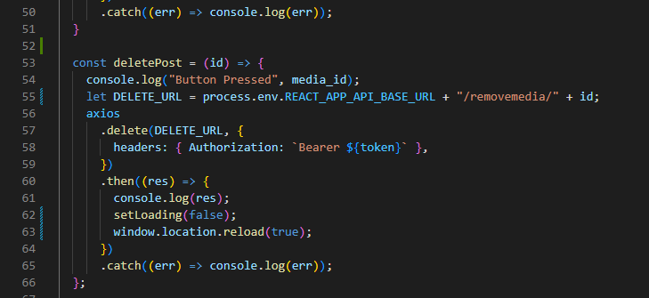

The path was not correct, it should be “/media/removemedia”. The media class was missing.

1. 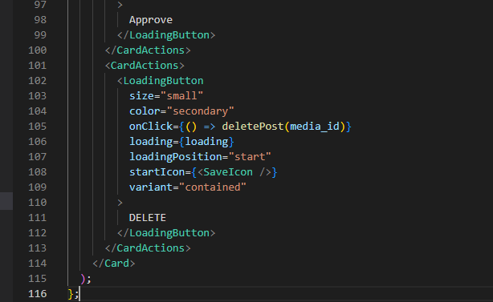

On clicking this button it redirects to the home page. The error message is also not shown.